context this purpose is for exhibition. scanning an object for qc puporse. my task show the qc result to dashboard
Ah, okay — now I understand the exhibition setup and your actual task.
From the photos, you're working with a CREAFORM HandySCAN SILVER series 3D scanner and its scanning software. The scanner is capturing the physical part, while your laptop is displaying the 3D scan data.
Your task is not to build the scanner itself. Your task is basically:
Take the QC/inspection result produced from the 3D scanning process → extract the important QC information → display it on a dashboard.
The overall system can look like this
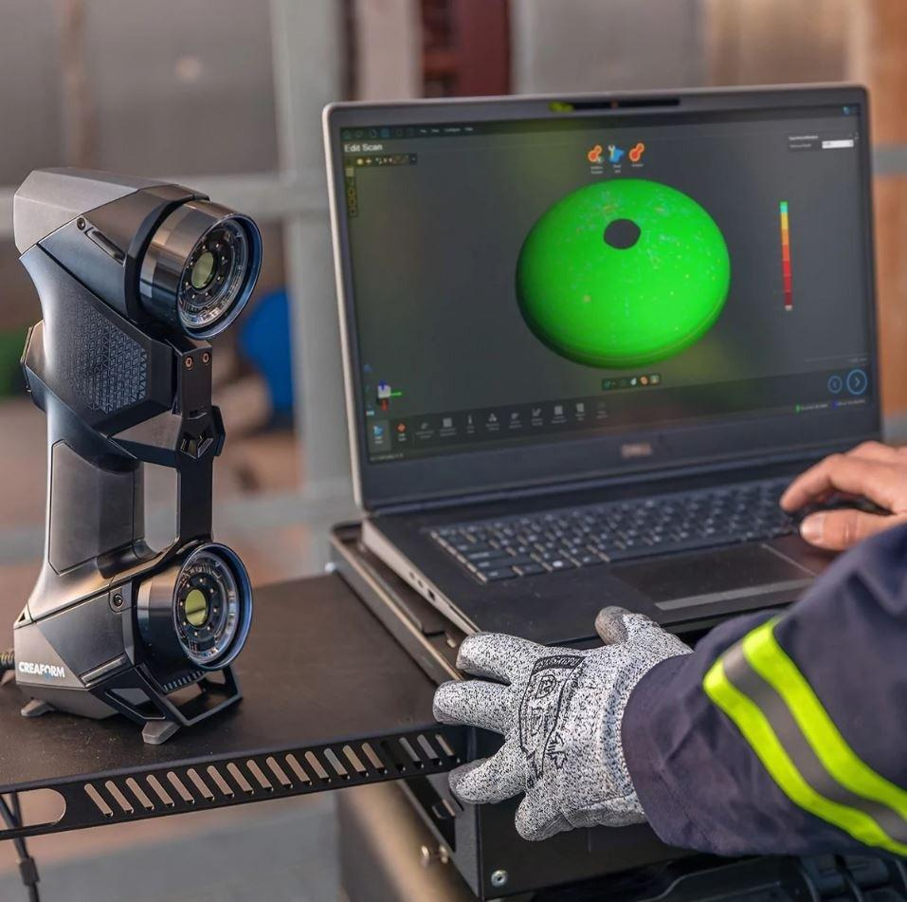
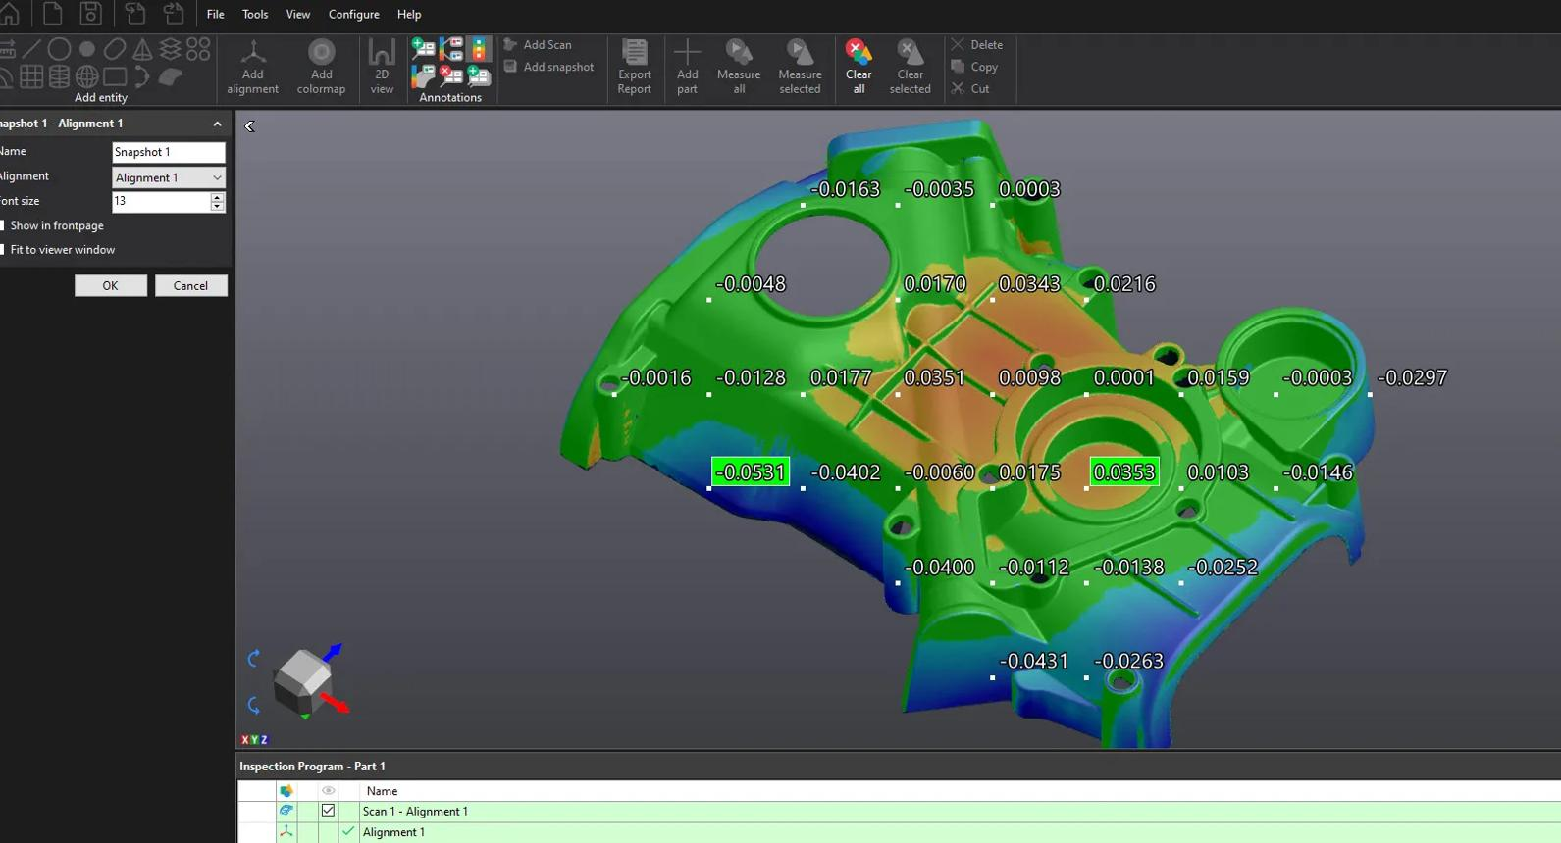
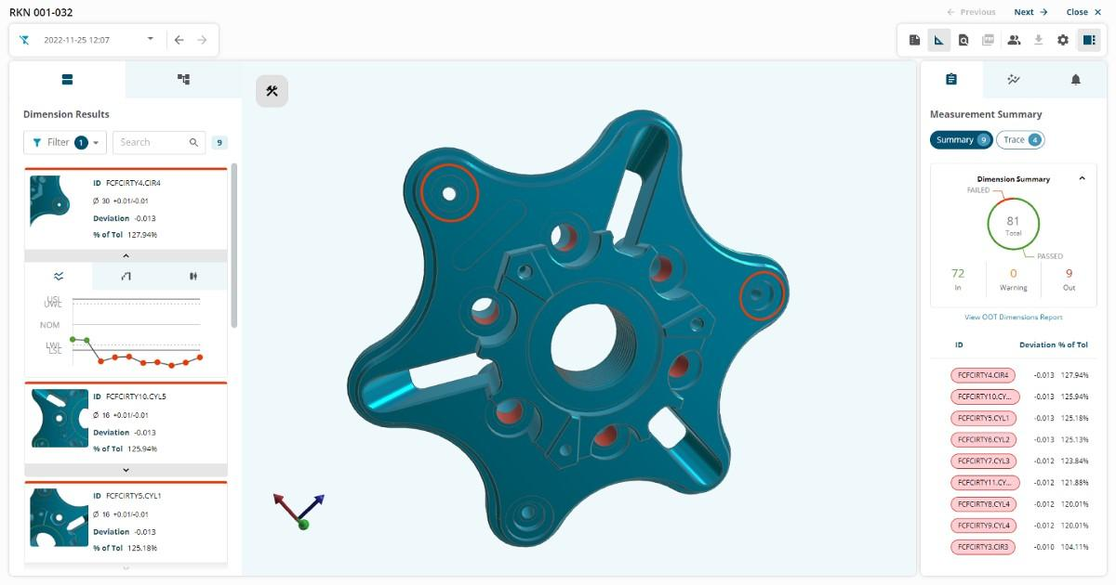
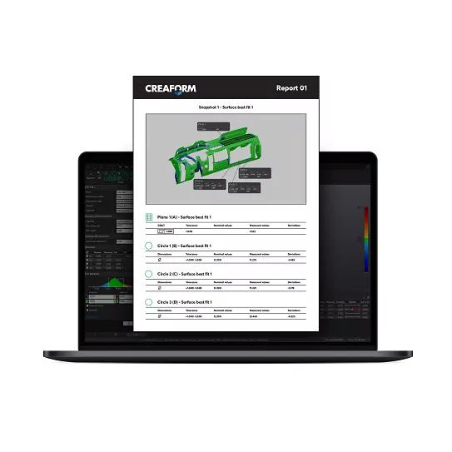
Physical Part
↓
CREAFORM 3D Scanner
↓
3D Scan Data
↓
VXelements / Inspection Software
↓
QC / Inspection Result
↓
┌───────────────────────┐
│ QC DATA │
│ │
│ Dimension │
│ Deviation │
│ Tolerance │
│ Pass / Fail │
│ Inspection Time │
│ Part ID │
└───────────┬───────────┘
↓
Your Dashboard
What I think your exhibition should demonstrate
You don't necessarily need to make the dashboard control the scanner.
Instead, demonstrate a QC information pipeline.
For example, after scanning a metal component:
QC Parameter | Example
Part ID | PART-001
Scan ID | SCAN-2026-001
Inspection Date | 18/08/2026
Dimensions Checked | 12
Passed | 10
Failed | 2
Max Deviation | +0.42 mm
Min Deviation | -0.18 mm
Overall Result | FAIL
Then the dashboard could show something like:
╔══════════════════════════════════════════════╗
║ 3D SCANNING QC DASHBOARD ║
╠══════════════════════════════════════════════╣
║ ║
║ PART ID INSPECTION RESULT ║
║ PART-001 ❌ FAIL ║
║ ║
║ ┌──────────┐ ┌──────────┐ ┌─────────────┐ ║
║ │ 12 │ │ 10 │ │ 2 │ ║
║ │ CHECKED │ │ PASS │ │ FAIL │ ║
║ └──────────┘ └──────────┘ └─────────────┘ ║
║ ║
║ MAX DEVIATION +0.42 mm ║
║ MIN DEVIATION -0.18 mm ║
║ ║
║ INSPECTION TIME 2:53 PM ║
║ ║
║ [3D SCAN / DEVIATION VISUALIZATION] ║
║ ║
╚══════════════════════════════════════════════╝
The important question is: where does your QC data come from?
This is the part I'd investigate first.
From your second photo, I can see the Creaform software displaying the scan and parameters such as:
- Target diameter: 6 mm
- Target reflectivity: Normal
- HDR mode
- Shutter: 0.15 ms
- positioning/scanner parameters
- the scanned point/geometry data
But those aren't necessarily your final QC results.
Your QC result might instead be generated later by an inspection/measurement workflow, for example:
Scan
↓
Alignment
↓
Compare scan against CAD/reference
↓
Measure dimensions/features
↓
Tolerance evaluation
↓
PASS / FAIL
That's the data your dashboard should ideally consume.

I would structure your project into 3 layers
1. Scanner / QC layer
Creaform scanner + software
This remains responsible for:
- scanning the part
- generating 3D data
- comparing against reference/CAD
- performing measurements
- determining deviations/tolerances
You don't need to reinvent this.
2. Data layer
This is probably your main engineering task.
You need to figure out how to get something like:
{
"part_id": "PART-001",
"inspection_id": "INS-001",
"timestamp": "2026-08-18 14:53:48",
"measurements": 12,
"passed": 10,
"failed": 2,
"max_deviation": 0.42,
"min_deviation": -0.18,
"result": "FAIL"
}
into your system.
This could potentially come from:
- exported inspection report
- CSV
- Excel
- database
- API
- software-generated file
- manually entered demo data
Which one you use depends on what the Creaform software available at your company/exhibition setup can actually export.
3. Dashboard
Then your dashboard turns the QC data into something understandable:
QC DASHBOARD
│
┌───────────────┼───────────────┐
↓ ↓ ↓
PASS/FAIL Measurements Deviation
│ │ │
↓ ↓ ↓
Overall QC Individual 3D/Graph
Results

For an exhibition, I'd make it more visual
You don't want visitors staring at a spreadsheet.
I'd aim for four dashboard sections:
🟢 Overall QC Status
Huge:
PASS
or
FAIL
📊 Inspection Summary
Measurements Checked 12
Passed 10
Failed 2
Pass Rate 83.3%
📏 Dimensional Results
Something like:
Feature | Nominal | Actual | Deviation | Result
Hole Ø1 | 6.00 mm | 6.02 mm | +0.02 | PASS
Hole Ø2 | 6.00 mm | 6.31 mm | +0.31 | FAIL
Length | 120.00 mm | 119.92 mm | -0.08 | PASS
🌈 3D Deviation
This is where the second photo becomes very useful.
The visitor sees:
Physical part → scanner → 3D model → deviation visualization → dashboard
That's a much stronger exhibition story than simply showing numbers.

And I think your project should have this exact story
"We scan a manufactured component, perform QC inspection, and visualize the inspection result on a dashboard."
So your exhibition flow becomes:
┌──────────────────┐
│ PHYSICAL PART │
└────────┬─────────┘
↓
┌──────────────────┐
│ 3D SCANNING │
│ CREAFORM │
└────────┬─────────┘
↓
┌──────────────────┐
│ 3D SCAN / CAD │
│ COMPARISON │
└────────┬─────────┘
↓
┌──────────────────┐
│ QC MEASUREMENTS │
│ + TOLERANCE │
└────────┬─────────┘
↓
┌──────────────────┐
│ DATA EXTRACTION │ ← YOUR TASK
└────────┬─────────┘
↓
┌──────────────────┐
│ DASHBOARD │ ← YOUR TASK
└────────┬─────────┘
↓
┌──────────────────┐
│ PASS / FAIL │
└──────────────────┘
One thing I'd not do yet
Don't immediately start coding a dashboard.
First determine exactly what QC output you can get from the Creaform system.
That's the critical dependency.
If you tell me what software is installed/being used on that Dell laptop (or send me a screenshot of the software's menus/export options), I can help you work out A → Z: what data to extract, how to store it, what dashboard technology to use, and how to make a working exhibition prototype.
Yes — that actually makes the exhibition concept much stronger. You can add a live CCTV/camera view of the robot operation alongside the QC dashboard.
I'd send Claude this updated instruction:
Updated Claude Prompt — QC Dashboard + Robot Live View
Continue with the previous project architecture, but add one more important feature:
ADDITIONAL FEATURE — ROBOT OPERATION LIVE VIEW
The exhibition will also have a robot involved in the inspection/manufacturing operation.
I want to add one camera/CCTV camera that provides a live view of the robot's operation.
The purpose is NOT to perform computer vision or automatically analyze the robot.
The purpose is simply:
Allow exhibition visitors to see the physical robot operation live while simultaneously viewing the QC result on the dashboard.
Updated Exhibition Concept
The complete exhibition experience should be:
Physical Part
↓
Robot Operation
↓
3D Scanning / Inspection
↓
QC Result
↓
Dashboard
At the same time:
Camera/CCTV
↓
Live Video Stream
↓
Dashboard
So the dashboard should combine:
- QC information
- Robot live camera view
- Inspection information
- PASS/FAIL result

Updated Architecture
Design the architecture approximately like this:
┌──────────────────────┐
│ PHYSICAL PART │
└──────────┬───────────┘
↓
┌──────────────────────┐
│ ROBOT OPERATION │
└──────────┬───────────┘
│
│
┌──────────▼───────────┐
│ 3D SCANNING │
│ CREAFORM SCANNER │
└──────────┬───────────┘
↓
┌──────────────────────┐
│ Creaform Inspection │
│ / QC Measurement │
└──────────┬───────────┘
↓
┌──────────────────────┐
│ QC DATA │
└──────────┬───────────┘
↓
┌──────────────────────┐
│ DATA PROCESSING │
└──────────┬───────────┘
↓
┌──────────────────────┐
│ DATABASE │
└──────────┬───────────┘
↓
┌──────────────────────┐
│ DASHBOARD │
└──────────────────────┘
↑
│
┌──────────┴───────────┐
│ LIVE CAMERA │
│ / CCTV │
└──────────────────────┘

Dashboard Layout
Design the dashboard so the live camera feed and QC information can be seen at the same time.
For example:
┌─────────────────────────────────────────────────────────────┐
│ 3D SCANNING QC DASHBOARD │
├────────────────────────────────┬────────────────────────────┤
│ │ │
│ ROBOT LIVE VIEW │ QC RESULT │
│ │ │
│ [ LIVE CAMERA ] │ PASS │
│ │ │
│ Robot operating │ Part ID: P-001 │
│ Area / Workcell │ Inspection: #001 │
│ │ Pass: 12 │
│ │ Fail: 0 │
├────────────────────────────────┼────────────────────────────┤
│ │ │
│ INSPECTION DATA │ DEVIATION │
│ │ │
│ Measurements: 12 │ Max: +0.08 mm │
│ Passed: 12 │ Min: -0.05 mm │
│ Failed: 0 │ │
│ Pass Rate: 100% │ [GRAPH] │
│ │ │
├────────────────────────────────┴────────────────────────────┤
│ INSPECTION HISTORY │
└─────────────────────────────────────────────────────────────┘

Camera Requirements
Help me determine the simplest way to provide the live camera view.
Compare possible approaches:
Option 1 — USB Webcam
Camera
→ USB
→ Exhibition PC
→ Dashboard
Option 2 — IP CCTV Camera
Camera
→ Network
→ RTSP/HTTP stream
→ Dashboard
Option 3 — Existing CCTV System
CCTV
→ Existing NVR/network
→ Dashboard
Option 4 — Phone/Tablet Camera
Only consider this as a temporary demonstration option.
For each option explain:
- Cost
- Difficulty
- Video latency
- Reliability
- Network requirements
- Ease of integration
- Suitability for an exhibition
- Whether it can run alongside the QC dashboard
Then recommend the simplest reliable option.

IMPORTANT — Separate Camera From QC
The camera does NOT determine the QC result.
The responsibilities should remain separate:
Creaform
Responsible for:
- 3D scanning
- 3D data
- inspection
- measurements
- deviation
- tolerance
- QC PASS/FAIL
Camera
Responsible for:
- live visual monitoring
- showing robot operation
- giving exhibition visitors a view of the physical process
Dashboard
Responsible for:
- displaying QC results
- displaying inspection information
- displaying live camera feed
- displaying inspection history
- presenting everything in a simple exhibition-friendly interface

Optional Future Feature
Do NOT implement this initially, but design the architecture so computer vision could potentially be added later.
Possible future features:
- Robot activity detection
- Part presence detection
- Cycle counting
- Camera snapshot when inspection starts
- Camera snapshot when inspection finishes
- Linking a camera timestamp to an inspection ID
For now, the camera should simply provide a live video feed.

Updated Exhibition Story
The visitor should experience something like:
- A physical component enters the robot/workcell.
- The robot performs its operation.
- The camera shows the robot operation live.
- The component is scanned using the Creaform scanner.
- The Creaform system performs QC inspection.
- QC data is transferred to the dashboard.
- The dashboard updates.
- The visitor sees:
ROBOT LIVE VIEW
+
QC MEASUREMENT
+
PASS/FAIL RESULT
The main exhibition message should be:
"Automated inspection with live process monitoring and real-time QC visualization."
If actual real-time QC integration is not available, do NOT falsely call it real-time. Clearly distinguish between:
- live camera streaming
- QC data update
- simulated/demo data
- actual Creaform integration

Updated System Requirements
Add the following to the project requirements:
Functional Requirements
FR1 — System shall receive/import QC inspection results.
FR2 — System shall display overall PASS/FAIL status.
FR3 — System shall display individual measurement results.
FR4 — System shall display inspection history.
FR5 — System shall display the robot operation through a live camera feed.
FR6 — System shall allow the camera feed and QC dashboard to be viewed simultaneously.
FR7 — System shall clearly indicate when the camera is LIVE.
FR8 — System should associate an inspection with a timestamp.
FR9 — System should be designed so that camera integration does not interfere with QC data processing.
Non-Functional Requirements
NFR1 — Dashboard should be suitable for an exhibition display.
NFR2 — Interface should be understandable to non-technical visitors.
NFR3 — Live video should have reasonably low latency.
NFR4 — System should remain stable during continuous exhibition operation.
NFR5 — If network connectivity is lost, the QC dashboard should still display previously received data.
NFR6 — Camera failure should not cause the QC application to crash.

What I Want From You Now
Update the architecture based on this new camera requirement.
Then provide:
- Updated system architecture
- Updated data flow
- Updated dashboard wireframe
- Recommended camera architecture
- Recommended dashboard technology
- Network architecture
- How the camera stream gets into the dashboard
- How QC data gets into the dashboard
- How both are displayed simultaneously
- Potential synchronization between robot operation, camera timestamp, and QC inspection timestamp
- Exhibition demo sequence
- Hardware/software requirements
Keep the implementation beginner-friendly.
Do not start coding yet.
First make sure the architecture is correct.
other than node red, which one has a better looking dashboard
Yes. If your priority is “looks impressive at an exhibition”, I would put Node-RED below several other options.
For your specific project — Creaform QC + robot live camera + inspection history + PASS/FAIL dashboard — I'd rank them like this:
Option | Visual quality | Difficulty | Live camera | QC data | My take
React + modern UI | ⭐⭐⭐⭐⭐ | ⭐⭐⭐⭐ | ⭐⭐⭐⭐⭐ | ⭐⭐⭐⭐⭐ | 🥇 Best-looking
HTML/CSS/JS | ⭐⭐⭐⭐⭐ | ⭐⭐⭐ | ⭐⭐⭐⭐⭐ | ⭐⭐⭐⭐ | 🥈 Great balance
Streamlit | ⭐⭐⭐⭐ | ⭐⭐ | ⭐⭐⭐ | ⭐⭐⭐⭐⭐ | 🥉 Easiest
Grafana | ⭐⭐⭐⭐ | ⭐⭐⭐ | ⭐⭐ | ⭐⭐⭐⭐⭐ | Great for data
Node-RED Dashboard | ⭐⭐⭐ | ⭐⭐ | ⭐⭐⭐⭐ | ⭐⭐⭐⭐⭐ | Easy industrial demo
Flask + HTML/CSS/JS | ⭐⭐⭐⭐⭐ | ⭐⭐⭐⭐ | ⭐⭐⭐⭐⭐ | ⭐⭐⭐⭐⭐ | Very flexible
🥇 My recommendation: React
If you're willing to learn a little more, React would give you the most impressive result.
You could make something like:
┌──────────────────────────────────────────────────────────────┐
│ SMART QC INSPECTION SYSTEM ● SYSTEM LIVE │
├────────────────────────────────┬─────────────────────────────┤
│ │ │
│ 🤖 ROBOT LIVE VIEW │ QC RESULT │
│ │ │
│ ┌──────────────────┐ │ ✓ PASS │
│ │ │ │ │
│ │ LIVE CAMERA │ │ PART-001 │
│ │ │ │ Inspection #024 │
│ │ ROBOT │ │ │
│ │ │ │ 12 / 12 Measurements │
│ └──────────────────┘ │ Pass Rate: 100% │
│ │ │
├────────────────────────────────┼─────────────────────────────┤
│ │ │
│ INSPECTION RESULTS │ DEVIATION │
│ │ │
│ Feature Actual Status │ +0.10 mm │
│ Hole 1 6.02 ✓ │ ───────●──── │
│ Hole 2 6.01 ✓ │ -0.10 mm │
│ Length 119.98 ✓ │ │
│ │ │
├────────────────────────────────┴─────────────────────────────┤
│ INSPECTION HISTORY │
│ #024 PART-001 100% ✓ #023 PART-001 91.7% ✓ │
└──────────────────────────────────────────────────────────────┘
And you can make it look like a real industrial monitoring system, rather than a developer dashboard.

But there's an even easier option
If you're still learning VS Code/programming, I'd seriously consider:
HTML + CSS + JavaScript
You don't necessarily need React.
You can build a very polished dashboard using:
- HTML → dashboard structure
- CSS → professional appearance
- JavaScript → dashboard logic
- Chart.js → graphs
- WebSocket/HTTP → live data
- <video> → camera feed
- Python/Flask → backend
- SQLite → QC history
Architecture:
CREAFORM
│
│ QC DATA
▼
┌───────────┐
│ PYTHON │
│ BACKEND │
└─────┬─────┘
│
┌─────▼─────┐
│ SQLite │
│ Database │
└─────┬─────┘
│
▼
┌─────────────────────────┐
│ WEB DASHBOARD │
│ │
│ HTML + CSS + JS │
│ │
│ ┌─────────┐ ┌───────┐ │
│ │ CAMERA │ │ QC │ │
│ │ LIVE │ │ RESULT│ │
│ └─────────┘ └───────┘ │
│ │
│ Measurements / Charts │
│ Inspection History │
└─────────────────────────┘
For your project, this is probably the sweet spot.
You get almost the same visual freedom as React without introducing a big framework.

What about Streamlit?
Streamlit is much easier.
You can get a dashboard running very quickly with Python.
But there is a trade-off.
It tends to look more like:
"Engineering/data analysis application"
rather than:
"Professional industrial monitoring system."
You can customize Streamlit heavily, but if you're already going to spend time designing the UI, I'd rather give you HTML/CSS/JS.

And what about Grafana?
Grafana is actually quite good for your QC data.
For example:
QC MONITORING
┌───────────────────────────────────┐
│ │
│ PASS │
│ │
│ 96.7% PASS RATE │
│ │
├───────────────┬───────────────────┤
│ Measurements │ Deviation │
│ 120 │ ───╱╲─── │
├───────────────┴───────────────────┤
│ Inspection History │
│ ──────────────────────────────── │
└───────────────────────────────────┘
It's excellent for graphs, trends, statistics and historical QC data.
But your project has an unusual requirement:
LIVE ROBOT CAMERA
That's where Grafana isn't my first choice.

So I'd choose this for you
Considering your exhibition:
🥇 HTML + CSS + JavaScript + Python
Best overall.
YOUR SYSTEM
│
┌────────────┴────────────┐
│ │
QC DATA CAMERA
│ │
▼ ▼
Python API Video Stream
│ │
└──────────┬──────────────┘
▼
WEB DASHBOARD
│
┌─────────────┼─────────────┐
▼ ▼ ▼
QC STATUS LIVE ROBOT INSPECTION
PASS/FAIL VIEW HISTORY
🥈 React + Python
If you want to make it really polished and you're willing to learn more.
🥉 Streamlit
If your priority becomes "I need this working quickly."

One more thing
Because you're doing this for an exhibition, I wouldn't optimize purely for "easiest to code."
I'd optimize for:
Looks professional + reliable + easy to demonstrate + easy for you to explain.
That's why I'd lean toward HTML/CSS/JS + Python backend for you rather than Node-RED.
And your dashboard could potentially be displayed full-screen on a large monitor while the live robot camera occupies ~40% of the screen and the QC result occupies ~60%. That would look much more like an actual industrial monitoring system.
Today 8:17 AM
teach me how to setup all those step by step
Yes. We're going to build this from absolute zero, as if you've never used VS Code before.
Your final exhibition system will be this:

Notice something important:
- Creaform does the scanning and QC inspection.
- Your Python system receives the QC result.
- Your dashboard displays the result beautifully.
- The camera only shows the robot live.
- The camera does not decide PASS or FAIL.
What we'll build
We are going to use this stack:

VS Code
Editor
Where you write all your code.

Python
Backend
Handles QC data, CSV import, database and camera stream.

Flask
Web server
Connects Python with your browser dashboard.

SQLite
Database
Stores inspection history in one lightweight file.
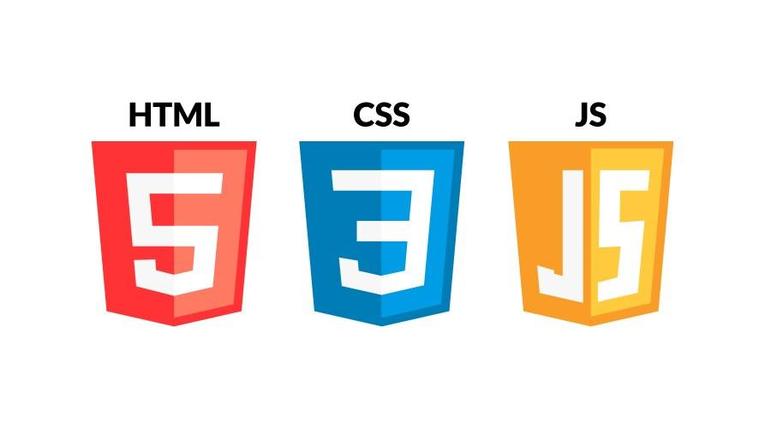
HTML + CSS + JavaScript
Frontend
Creates the professional-looking exhibition dashboard.
This is a real-world architecture. Flask is a lightweight Python web framework, VS Code officially supports Flask development and Python virtual environments, and SQLite is built into Python for lightweight databases.

Flask Documentation (3.1.x)+3
Learning roadmap
Don't try to learn everything in one night.
We'll build it in 8 phases.

Today we'll finish Phase 1 and Phase 2.
By the end, you'll already have a website running from VS Code.
Phase 1 — Install everything
Step 1. Install Python
Go to the official Python website and install the latest stable Python 3 release for Windows.
Download Python
Official website:

python.org
Download Python
Official Python downloads for Windows.
During installation:
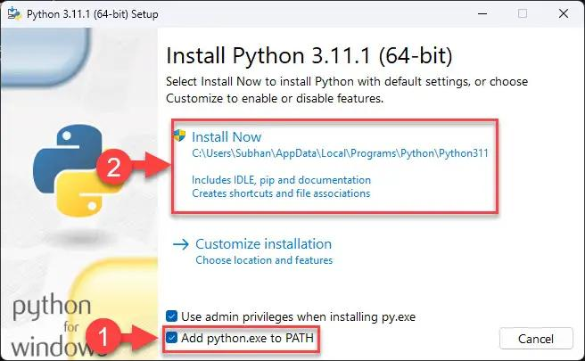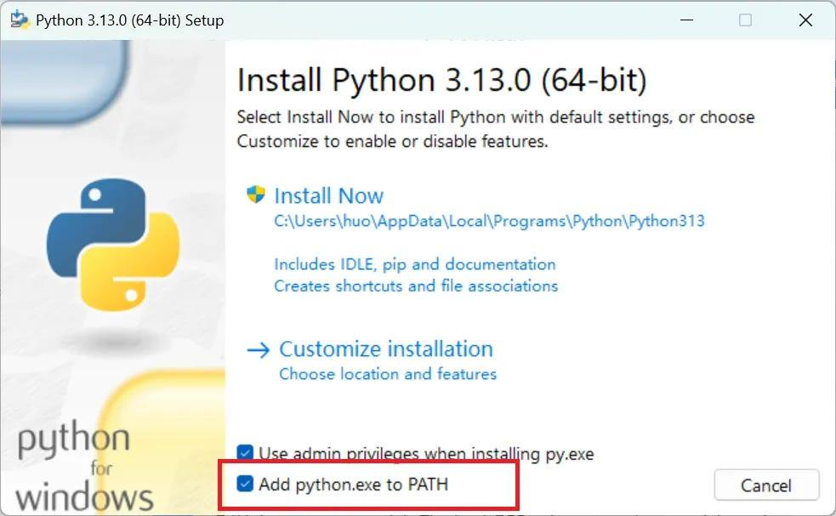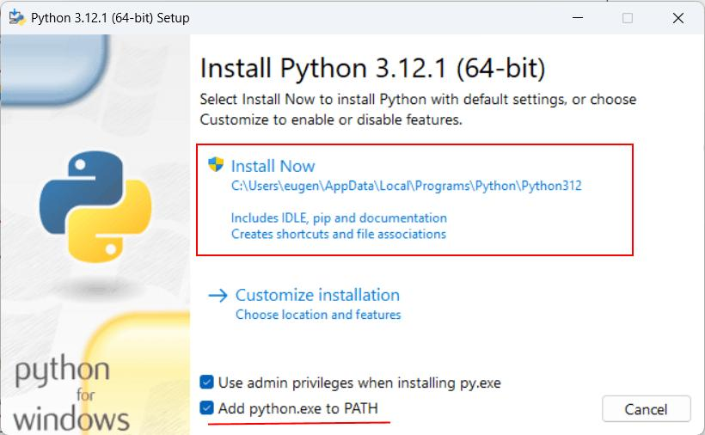
Very important: tick the checkbox:
Add Python to PATH
Then click Install Now.
After installation, open Command Prompt.
Type:
python --version
You should see something similar to:
Python 3.14.x
Any actively supported Python 3 version is fine. Python's official downloads and documentation are here.

Python.org+1
Step 2. Install VS Code
Download VS Code from Microsoft's official website.
Download VS Code

code.visualstudio.com
Visual Studio Code
Official VS Code download page.
Install normally.
Open it.
You'll see something similar:
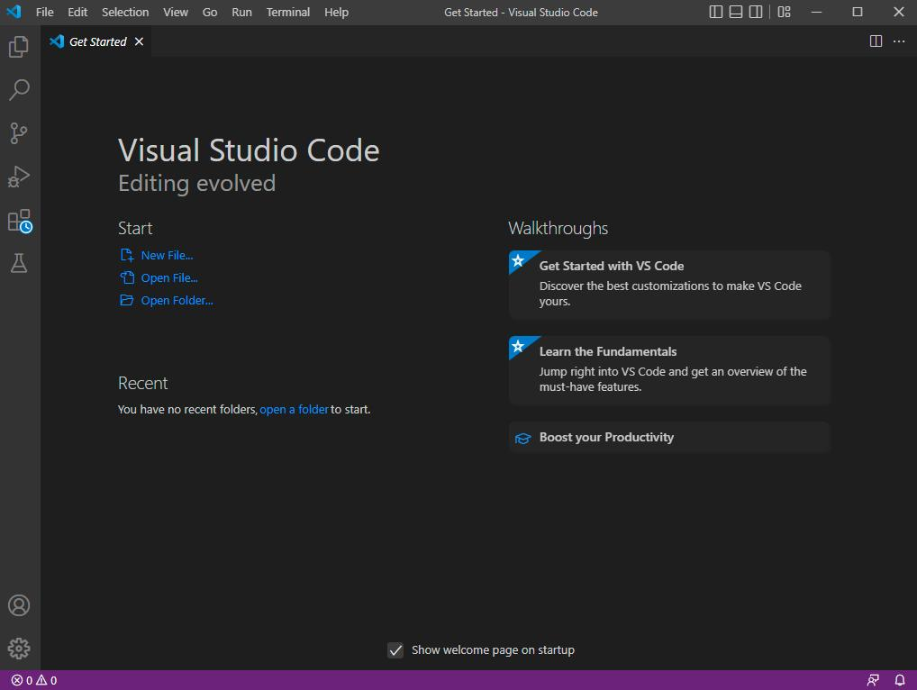
Step 3. Install Python Extension
Inside VS Code:

Press:
Ctrl + Shift + X
Search:
Python
Install the extension published by Microsoft. VS Code's official Python documentation recommends the Python extension for editing, debugging, IntelliSense, and environment management.

Visual Studio Code+1
Phase 2 — Create your project
Now we'll create the actual project.
Step 4. Create a folder
Create this folder anywhere.
I recommend Desktop first.
Desktop

└── qc_dashboard
Inside it, we'll eventually have:

Don't create everything manually yet.
We'll do it gradually.
Step 5. Open folder in VS Code
In VS Code:
File → Open Folder
Choose:
qc_dashboard
Now your Explorer should be empty.
That's correct.
Phase 3 — Terminal
This is where beginners usually get scared.
Don't.
The terminal is simply where you tell Python what to do.
Open it:
Terminal
↓
New Terminal
or press:
Ctrl + `
You'll see something like:
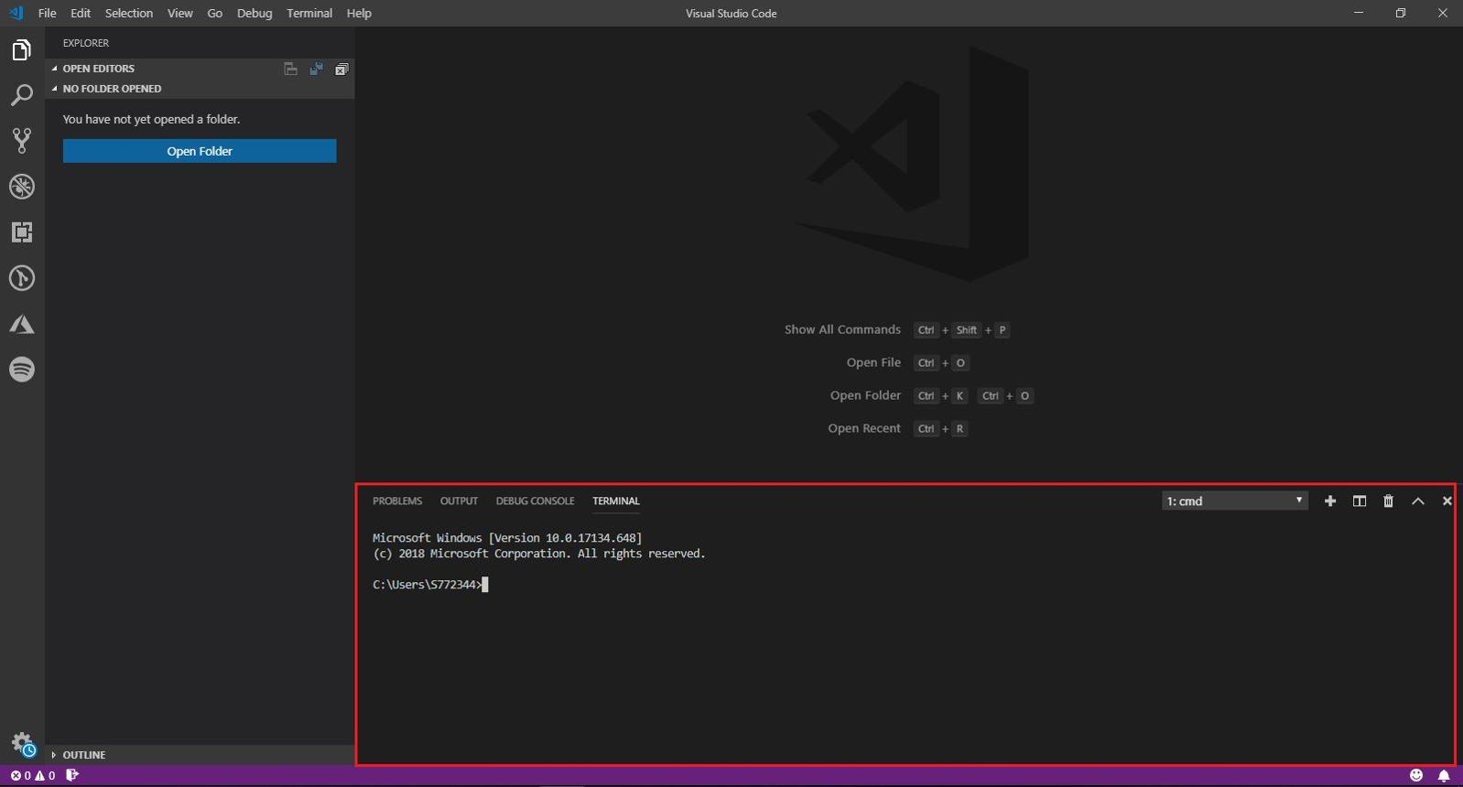
Phase 4 — Virtual Environment
What is a virtual environment?
Imagine every project has its own toolbox.
Your QC dashboard has one toolbox.
Another future project has another toolbox.
That's exactly what a virtual environment is.
Create it by typing:
python -m venv .venv
Press Enter.
Now you'll notice a folder appears:
qc_dashboard

├── .venv
Don't touch it.
VS Code manages it.
Activate it
Type:
.venv\Scripts\activate
Your terminal should change from:
C:\Users\Shaheer\Desktop\qc_dashboard>
to something like:
(.venv) C:\Users\Shaheer\Desktop\qc_dashboard>
The (.venv) means success.
VS Code and Flask both officially recommend using a virtual environment for project dependencies.

Visual Studio Code+2
Phase 5 — Install Flask
Type:
pip install flask
Wait until it finishes.
Then verify:
pip show flask
You should see Flask information.
Flask's official installation and Quickstart documentation use this same workflow.

Flask Documentation (3.1.x)+1
Phase 6 — Create your first website
Now create one file.
Inside VS Code Explorer:
Right click
→ New File
Name it:
app.py
Paste this code.
{`from flask import Flask

app = Flask(__name__)

@app.route("/")
def home():
return "<h1>Hello Shaheer!</h1><p>QC Dashboard is working.</p>"

if __name__ == "__main__":
app.run(debug=True)`}
Save.
Press:
Ctrl + S
Phase 7 — Run the server
In terminal:
python app.py
You'll see:
Running on http://127.0.0.1:5000
Open your browser.
Type:
http://127.0.0.1:5000
You should see:

Congratulations.
You just created a web server.
Your laptop is now hosting a website.
No internet required.
Only your computer.
Understanding what just happened

When someone opens:
127.0.0.1:5000
this happens:
- Browser asks for the webpage.
- Flask receives the request.
- app.py runs.
- Flask sends HTML back.
- Browser displays it.
Later, instead of saying:
Hello Shaheer
it will display:
- PASS/FAIL
- Robot Camera
- Part ID
- Deviation
- Measurement Table
- Inspection History
Exactly the same concept.
Phase 8 — Create the real dashboard structure
Now we'll stop using plain text.
Create two folders.
Right click project.
Create:
templates
and
static
Your project becomes:
qc_dashboard

│ app.py
│
├── templates
│
└── static
Inside templates, create:
index.html
Inside static, create:
style.css
Now your project looks like this.

Replace app.py
Delete everything inside app.py.
Paste this instead.
{`from flask import Flask, render_template

app = Flask(__name__)

@app.route("/")
def home():
return render_template("index.html")

if __name__ == "__main__":
app.run(debug=True)`}
Notice one new thing.
Before:
return "Hello"
Now:
return render_template("index.html")
Meaning:
Flask, open the HTML file and show it.
Create index.html
Paste this.
{`<!DOCTYPE html>
<html>

<head>
<title>QC Dashboard</title>
<link rel="stylesheet" href="{{ url_for('static', filename='style.css') }}">
</head>

<body>

<h1>SMART QC INSPECTION DASHBOARD</h1>

<div class="container">

<div class="camera">
<h2>LIVE ROBOT VIEW</h2>

<div class="video-box">
CAMERA
</div>

</div>

<div class="result">

<h2>QC RESULT</h2>

<h3 class="pass">PASS</h3>

<p>Part ID : PART-001</p>

<p>Inspection : INS-001</p>

<p>Measurements : 12</p>

<p>Passed : 12</p>
Save.
Create style.css
Paste this.
{`body{
margin:0;
font-family:Arial;
background:#111827;
color:white;
}

h1{
text-align:center;
padding:20px;
}

.container{
display:flex;
gap:20px;
padding:20px;
}

.camera,
.result{
flex:1;
background:#1F2937;
padding:20px;
border-radius:12px;
}

.video-box{
height:350px;
background:black;
display:flex;
align-items:center;
justify-content:center;
font-size:30px;
}

.pass{
font-size:60px;
color:#22C55E;
text-align:center;
}`}
Save everything.
Run again.
python app.py
Refresh browser.
Now you'll see something resembling your exhibition dashboard.

That's already a proper foundation.
Your folder right now
Make sure yours looks exactly like this.

What each file does
File | Purpose
app.py | Python brain of the project
index.html | Dashboard structure
style.css | Dashboard appearance
.venv | Python toolbox
templates | HTML pages
static | CSS, JavaScript, images later
Remember this because you'll hear these names constantly.
Your next 6 milestones
Milestone 1: Setup complete
Python + VS Code + Flask running
Milestone 2: Professional industrial dashboard
Cards, charts, dark UI, responsive layout
Milestone 3: QC data becomes dynamic
Part ID, PASS, FAIL, deviation from Python
Milestone 4: SQLite database
Save every inspection and show history
Milestone 5: Live robot camera
USB webcam first, then CCTV/IP camera if needed
Milestone 6: Creaform integration
Import actual CSV/Excel/report data after confirming export format
Don't install these yet
A lot of tutorials tell beginners to install 20 libraries.
Don't.
For now, only Flask.
Later we'll add packages one by one:
Later package | Why
OpenCV | Live webcam
Pandas | Read CSV from Creaform
Chart.js | Beautiful graphs
SQLite | Already included with Python
Keeping it incremental makes debugging much easier. Flask, Python virtual environments, and SQLite are all supported through the official Python and VS Code workflows.

Flask Documentation (3.1.x)+3
Checkpoint
Before moving to the next lesson, verify these four things:
python --version works
VS Code has the Microsoft Python extension
Your terminal shows (.venv)
Opening 127.0.0.1:5000 displays your dashboard
If all four work, you've completed the foundation of the project exactly the way we'll need for the exhibition.
Next lesson: we'll transform this basic page into a real industrial QC dashboard with KPI cards, PASS/FAIL animation, measurement table, deviation chart, and a layout that looks similar to a professional factory monitoring HMI—before we even connect the Creaform data.

